Classification codes
Space heating

Task code 4EC084

Description This open-ended task requires students to consider the science behind home heating. It deals with both the transfer of energy and the options available for heating in the home.

Conceptual strand / context Natural and processed materials Life and living
Energy and change Earth and beyond

Task type Objective Open ended Practical

Learning outcome focus Concept Process

Task focus level 1 2 3 4 5 6

Assessment purpose Diagnostic Formative Summative

Keywords convection, radiation

Items | 1 | 2 | 3
Highest scientific literacy level
Conceptual strand / context
Domain
Response type
Assessment purpose

Task / Teacher record sheet

Student: _______________________

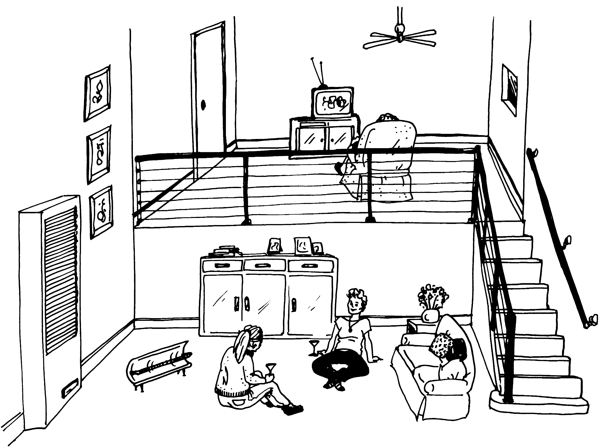

Some of these terms could be useful in the answers you are constructing.
Convection, conduction, radiation, circulation.

4EC084Q1
- A gas space heater has been installed on the lower level of this house. Most of the
family members’ time is spent on the upper level. This contains the kitchen, dining
room and television room. Give a scientific reason why the space heater was not put
on the upper level. Explain fully.

4EC084Q2
- When family members are using both upper and lower levels and the space heater is on,
the ceiling fan is also turned on. Explain the advantage in doing this.

In a wall space heater the gas fire is at the bottom. If you open the front of the heater you can see a large metal sheet. This metal sheet is directly above the fire and gets very hot. Air is drawn in at the bottom of the heater and forced over this sheet to heat the air.

4EC084Q3
- Explain why air is drawn in at the bottom and not the top of the heater.

Marking guide
4EC084Q1
Q1 | Score 2 | [5C–hard. Explains phenomenon in terms of several abstract concepts (transfer of heat creates convection current).]  Hot air rises and displaces cooler air. The cooler air falls and is reheated by the space heater on the lower level. If the heater was on the upper level the circulation of air would only occur there and the lower level would receive little benefit.  Actual student response:  - In the process of convection, the circulation of air is one in which hot air and cold air sinks. Therefore, if the heaters are placed downstairs, the theory is that the hot air will rise up to where they are.
 | Score 1 | [4C–medium. Explains process in terms of an abstract concept (heat transfer).]  Hot air rises. If the heater was on the upper level, the lower level would not get much benefit from the heater.  Actual student response:  - Because heat rises. If it was on the upper level and you were on the lower level you would be cold because the heat wouldn’t circulate downstairs.
 | Score 0 | Other.
4EC084Q2
Q2 | Score 1 | [4C–easy. Explains process in terms of an abstract concept (heat transfer).]  The ceiling fan mixes the air in the rooms. Thus the heat is distributed more evenly than otherwise. This prevents the upper level becoming warmer than the lower level.  Actual student responses:  - Turning the ceiling fan on, when both levels are being used, is an advantage because circulation of hot air increases rapidly compared to natural circulation.  - When the ceiling fan is on it moves the heat around two rooms, which heats up both rooms.
 | Score 0 | Other.

4EC084Q3
Q3 | Score 1 | [5C–hard. Explains phenomenon using several abstract concepts (heat transfer relates to efficient operation of heating system).]  The air at the bottom is cooler that the air at the top of the heater since hot air rises.  Actual student responses:  - The heater draws air from the bottom this is because the air is cooler down here, making this warm, is more logical than heating warm air.  - Circulation, the cold air is sucked into the bottom of the heater where it is then heated and let out as heat energy.
 | Score 0 | Other.

